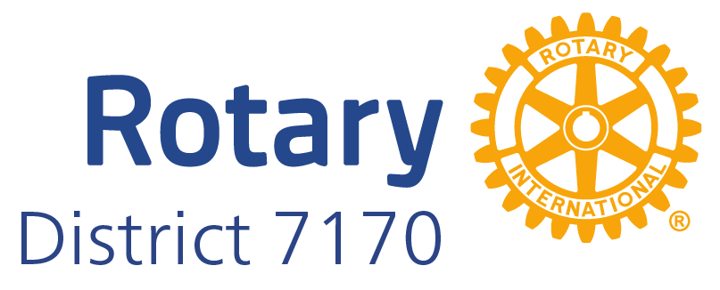
Reimbursement/Payment Expense Voucher
Expense Description | Account Name
Account Code | NNNN
Dates covering this request | MM/DD/YYYY | MM/DD/YYYY

Receipt Details:
Item Description | AMOUNT
2023 IRS mileage rate = 65.5 cents per mile
Total

Rotarian Requesting: | Name | Date: MM/DD/YYYY
Check Payable to: | Name
Address | Street  City, ST Zip
 | Receivers PayPal:

(Signature)
Mail with supporting receipts to: Rotary District 7170, c/o Rocky Martinez, 1224 Cherese Ln, Binghamton, NY 13905 or Email to: rockymartinez7170@yahoo.com

To All District 7170 Rotarians requesting an expense reimbursement:

- Expense Description is the Budgeted Category description (i.e., Asst. Governor Discretionary).
- Account Code is the Line Item Number (i.e. 5100 for Asst. Governor Discretionary.
- Item Description is the individual receipt description (i.e., Mileage, Meals, etc.). All these expenses will be charged to the Account Code above.
- District 7170 reimbursement requests will be processed upon the submission of an expense report on the District 7170 Expense Voucher form. The submissions should identify any actual expenditures incurred or invoices payable, and include supporting documentation (receipts, invoices etc.). The voucher form MUST include the budget line number(s) applicable to the expense OR, at a minimum, a full description of the purpose of the expense. The absence of adequate information can delay the payment of the reimbursement.

- Submitting the expense voucher form with an unpaid invoice and instructions that the payment should be made directly to a third party will provide the opportunity to affect a third party payment in lieu of a reimbursement.

- Mileage for trips made and directly related to the ordinary course of Rotary business and events related to your Rotary job function shall be reimbursed at the applicable IRS rate.

- Registration fees for Rotary functions approved and included as line items in the District Budget may be submitted for reimbursement either by first paying for them or by submitting copies of registration forms to be accompanied with a District check for the fees in question.

- Budget line items identify maximum limits of spending to be reimbursed for, with some flexibility possible through prior approval of the District Finance Committee. Line items are not cash allowances but limits of expense reimbursements of actual expenditures incurred.

- Lodging and Meal expenditures incurred in connection with Rotary functions and/or events shall be reimbursed upon submission of an expense voucher with the necessary receipts. No alcoholic beverages shall be reimbursed from the District; please exclude those charges from the expenses to be reimbursed.

- Any questions requiring clarification can be directed to Tony Salerno, District Treasurer at 607-227-5744 or by email to 7170treasurer@gmail.com.

- Submitted quarterly (first business day after the end of the quarter)

- October 2nd, 2023
- January 2nd, 2024
- April 1st, 2024
- June 30th, 2024

